CS303 – Logic & Digital System Design

**CS303 – Lab#2 Report**

**Name-Surname/SID:** Barışcan Köse/25413

**1.Project Description**

In this lab, I’m going to build 2 different versions of 15-bit adders/subtractors. First design will be of a 15-bit ripple carry adder/subtractor consisting of full adders connected in sequence. In the second design, I will be creating a 15-bit carry-lookahead adder. Both of the designs will have their schematic screenshots attached. I will also show the behavioural simulatin of the designs in which there will examples of a properly working adder/subtractor. I will also provide synthesis and implementation reports in which Map Report will give us the area of the designs and POST-PAR static timing report will give us the speed of the designs.

**2.First Design**

**2.1. Schematic**

First photo is of the full-adder. Second photo is the schematic of the 15-bit ripple carry adder. 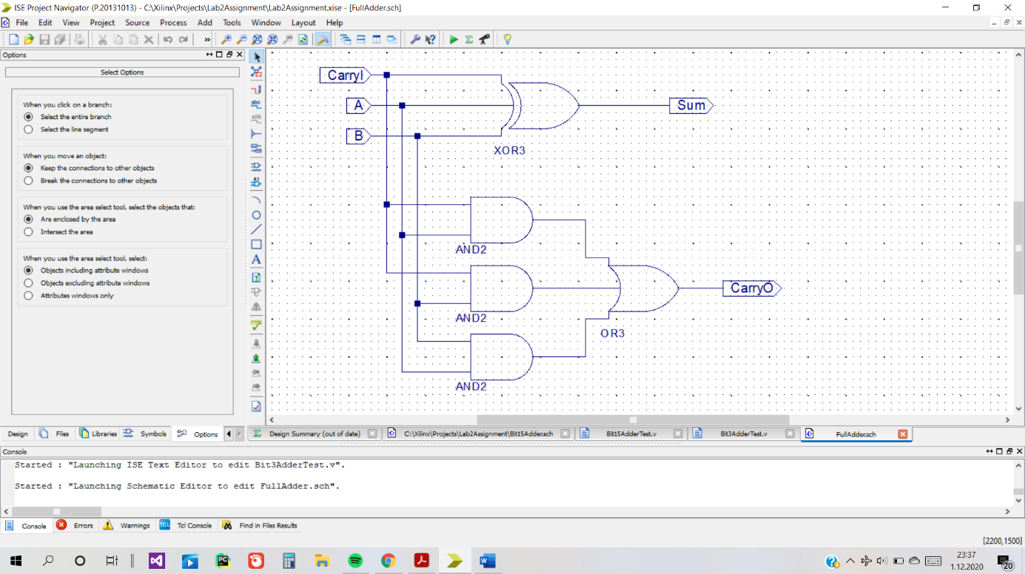

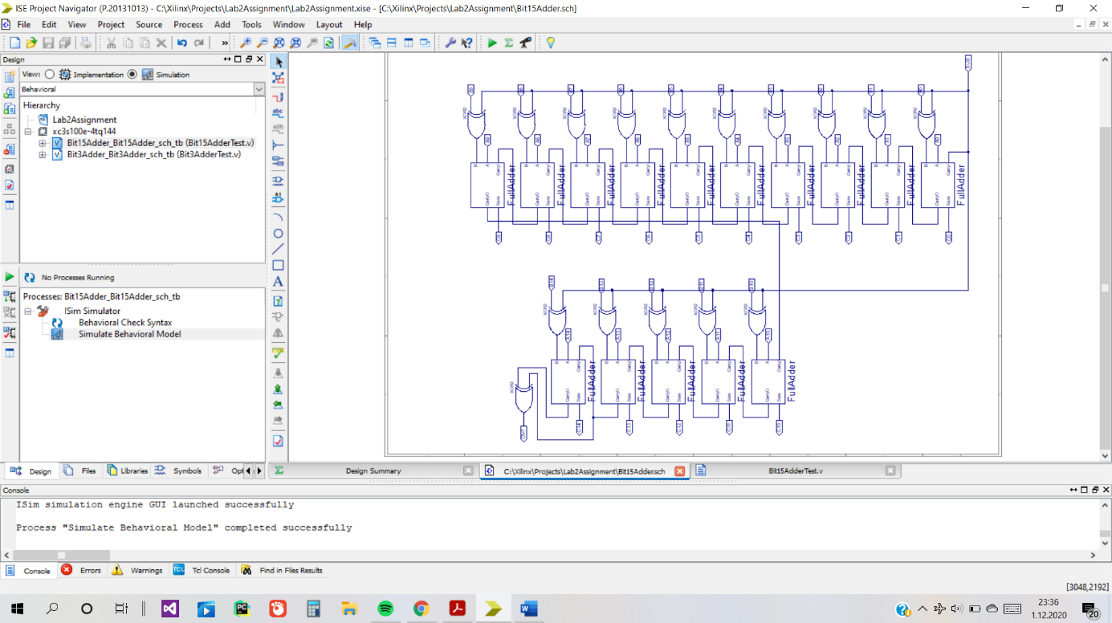

**2.2. Simulation**

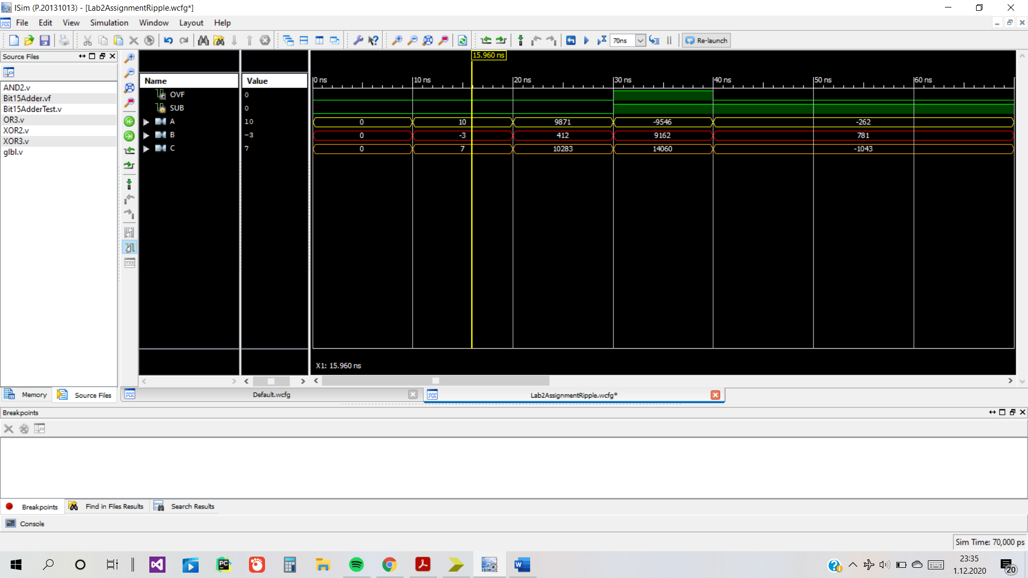

**2.3. Implementation Results**

The first design uses 30 4-input LUTs and its maximum actual delay is 25.182 ns which is from SUB to OVF.

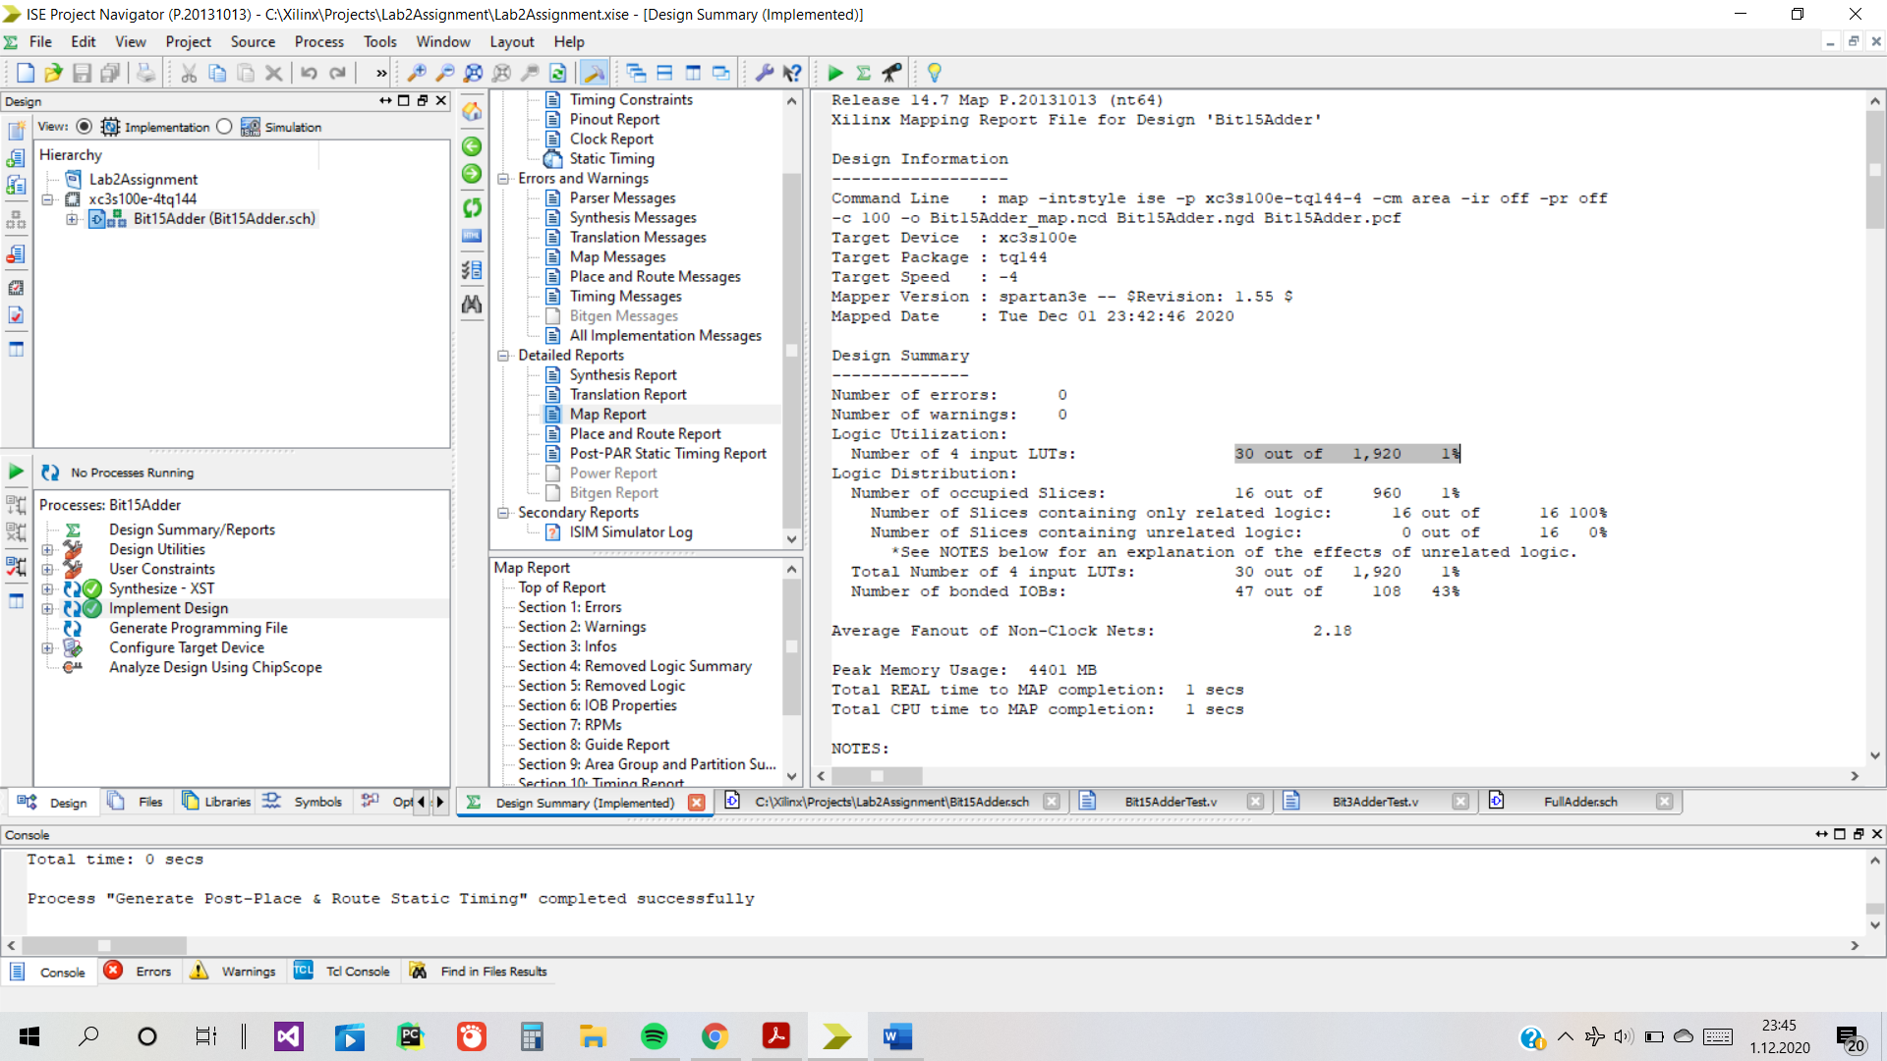

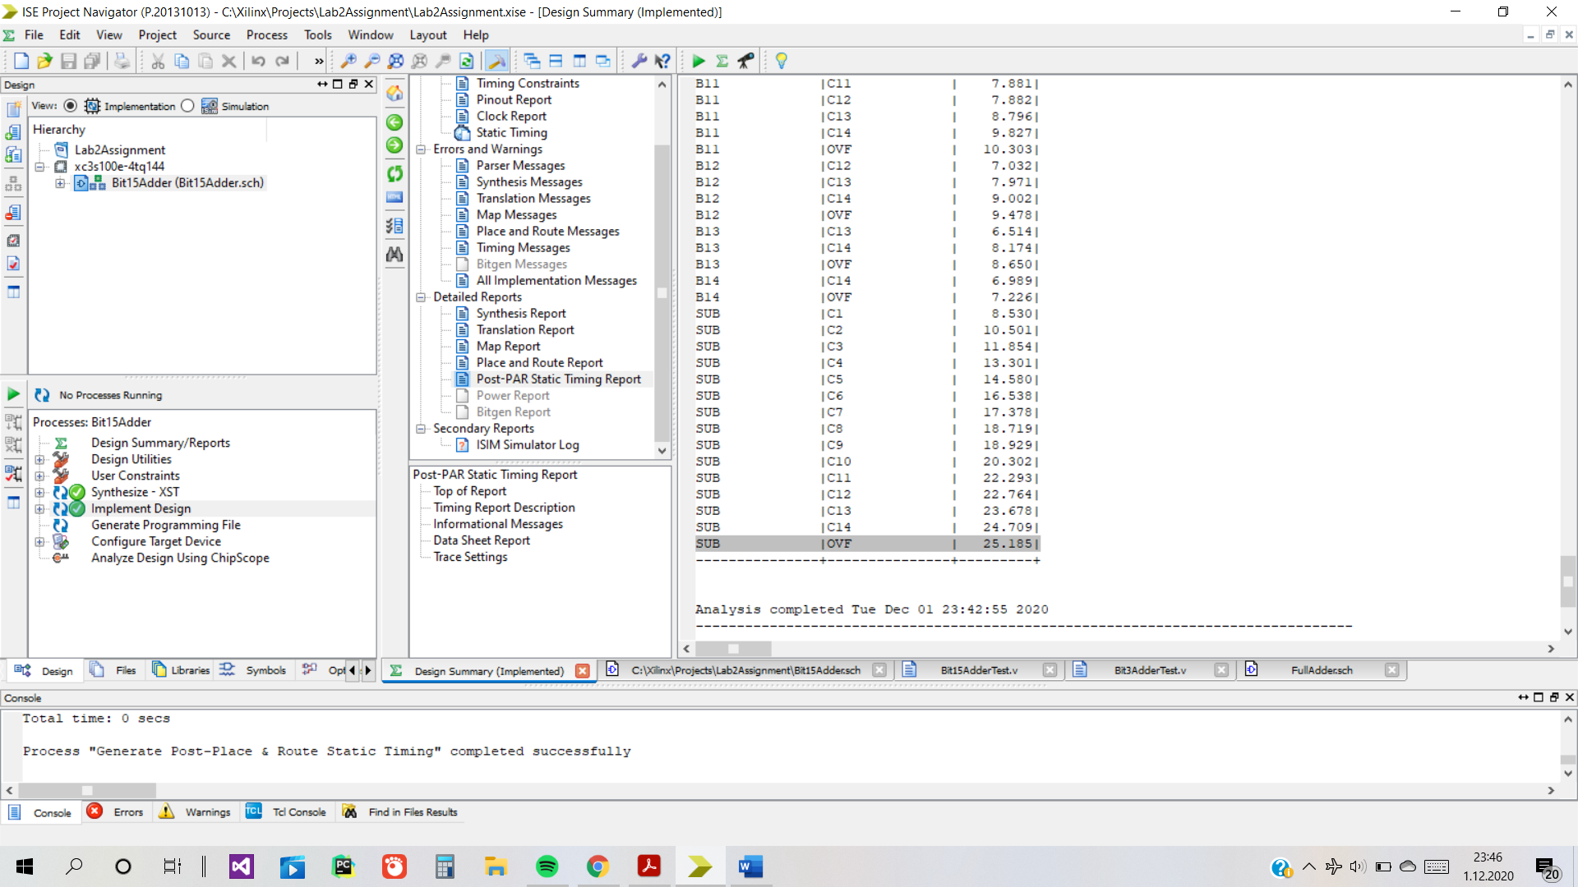

**3.Second Design**

**3.1. Schematic**

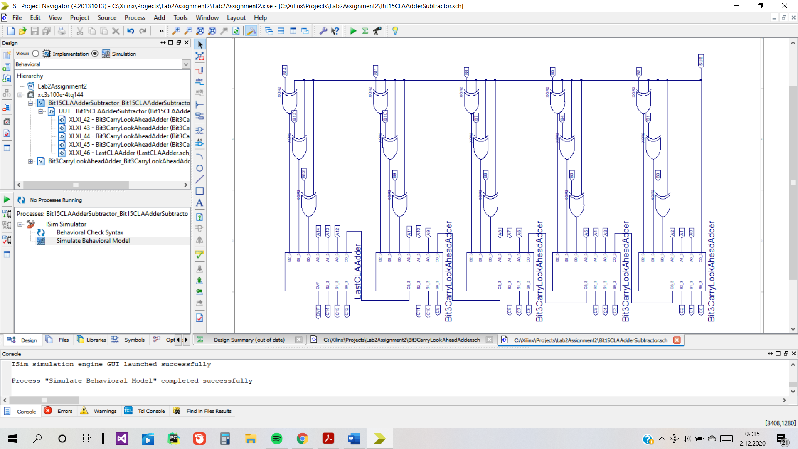

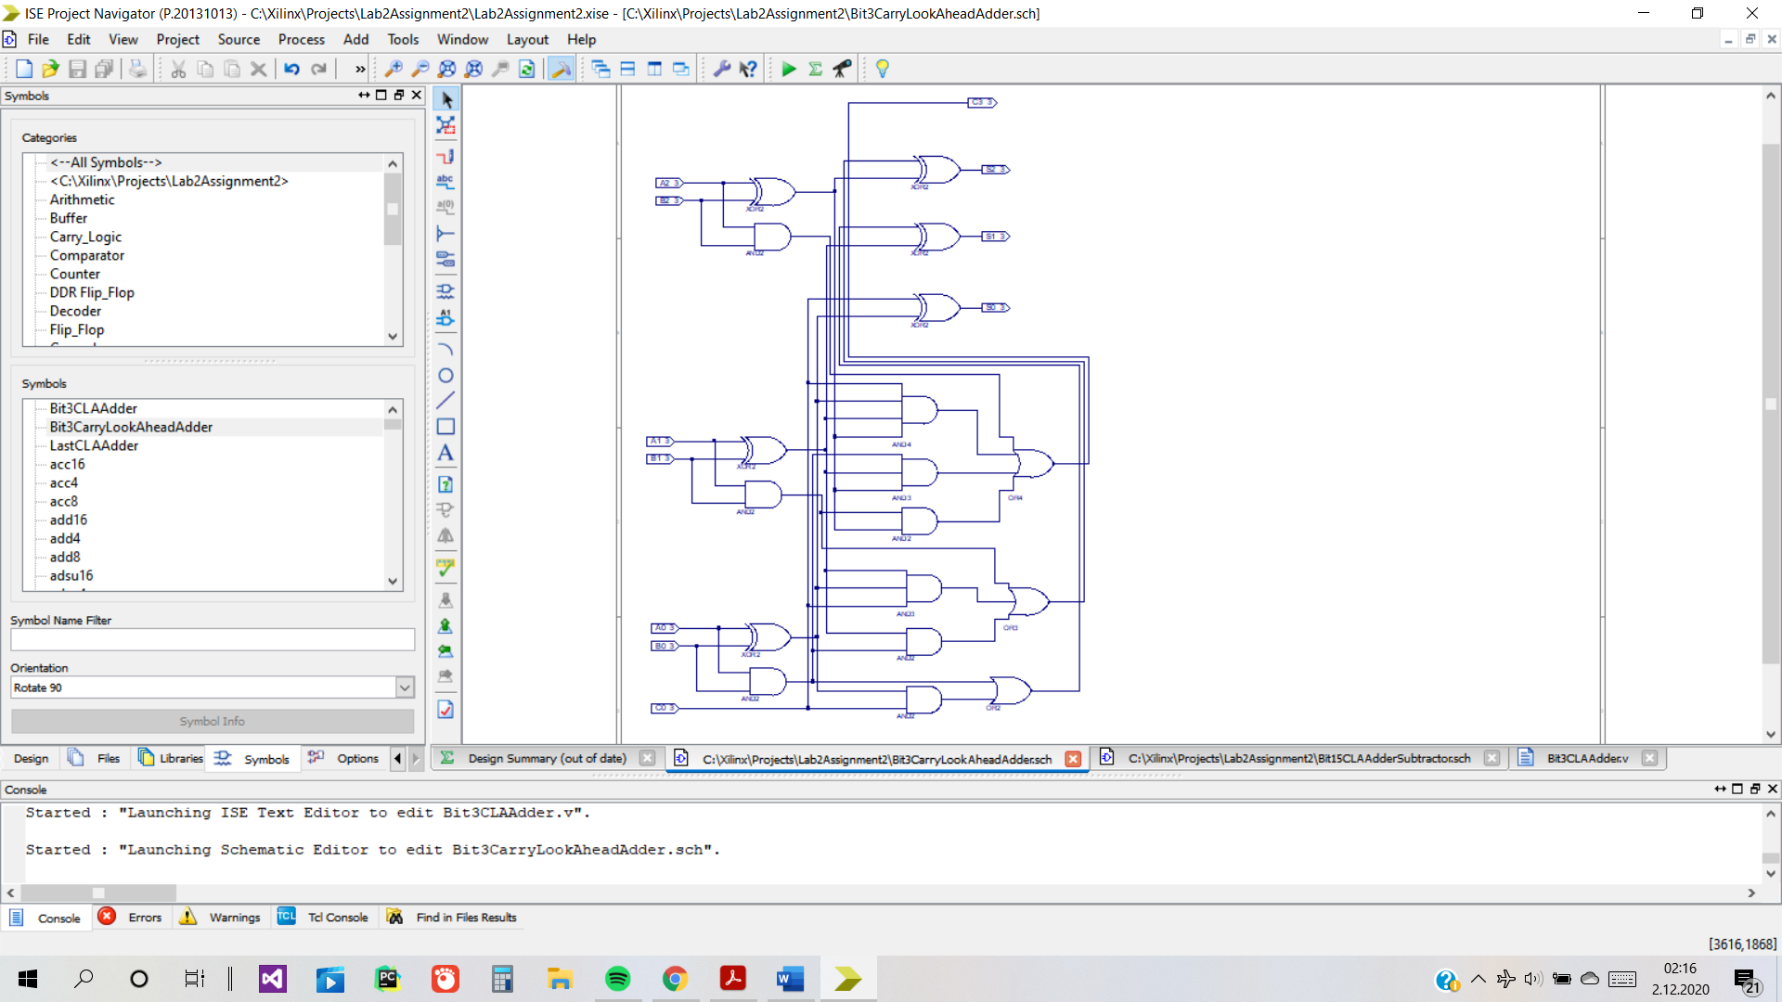

This is the last CLA Adder that gives OVF at C3_3.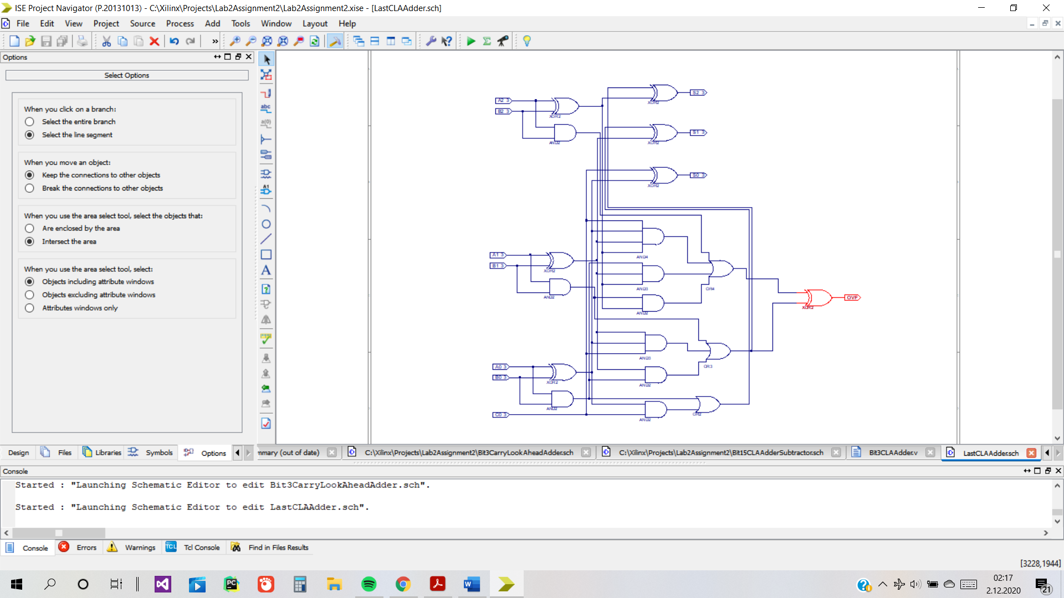

**3.2. Simulation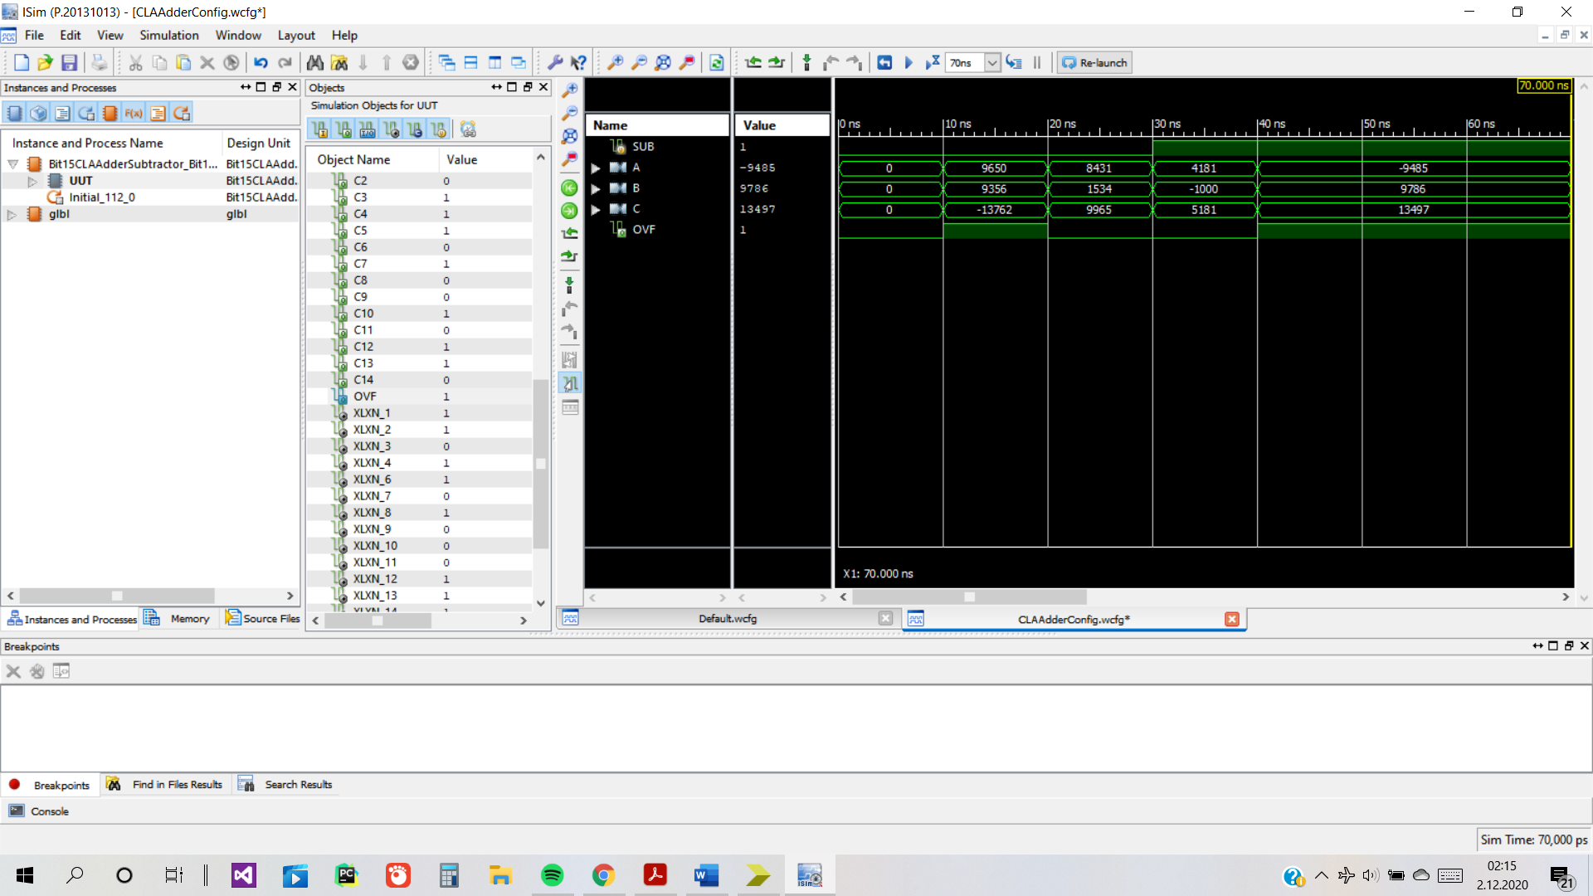3.3.Implementation Results**

The second design used 80 4-input LUTs and had actual maximum delay of 22.058 again between SUB and OVF.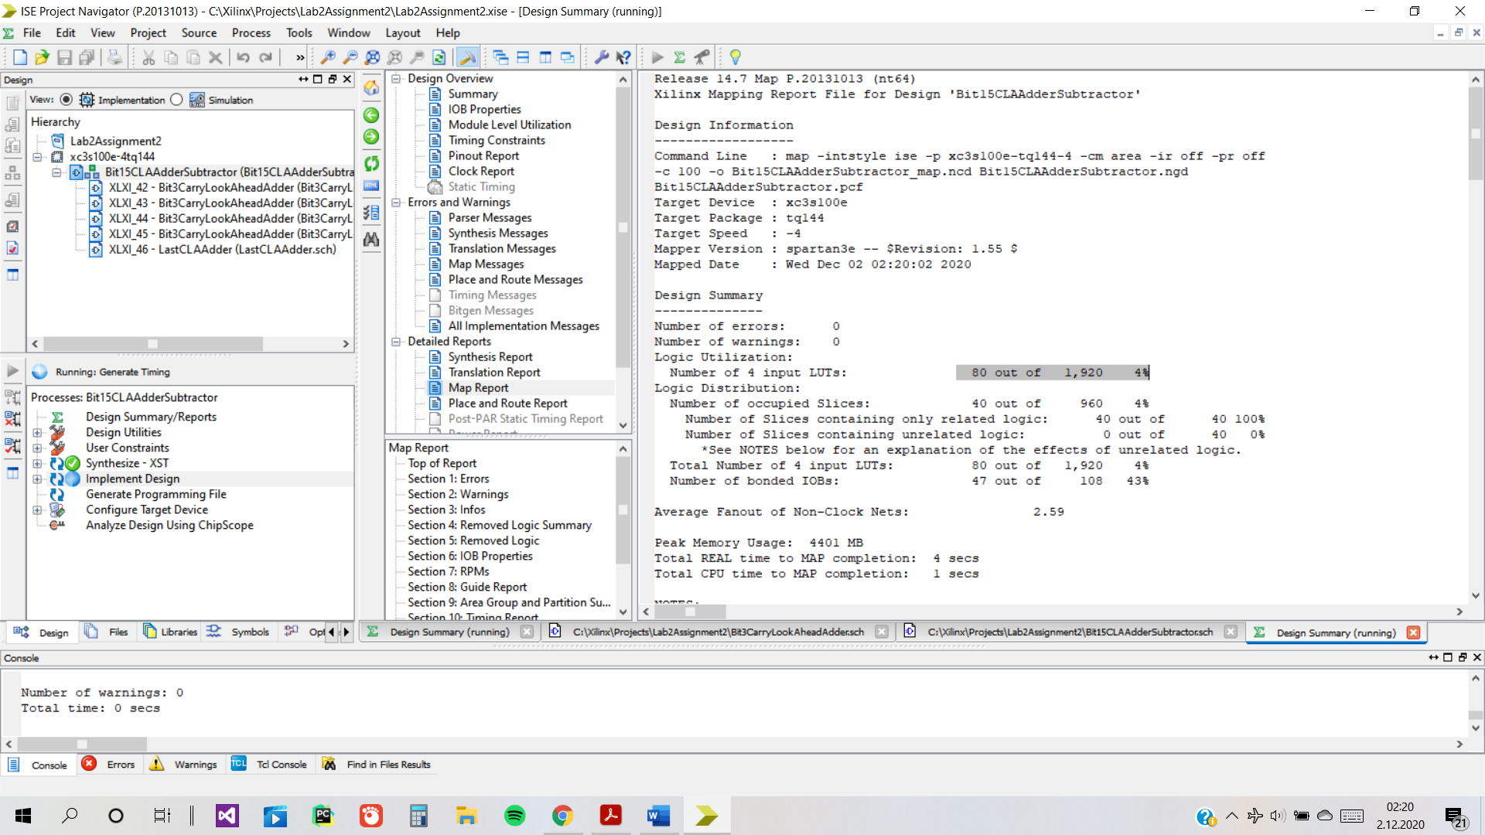

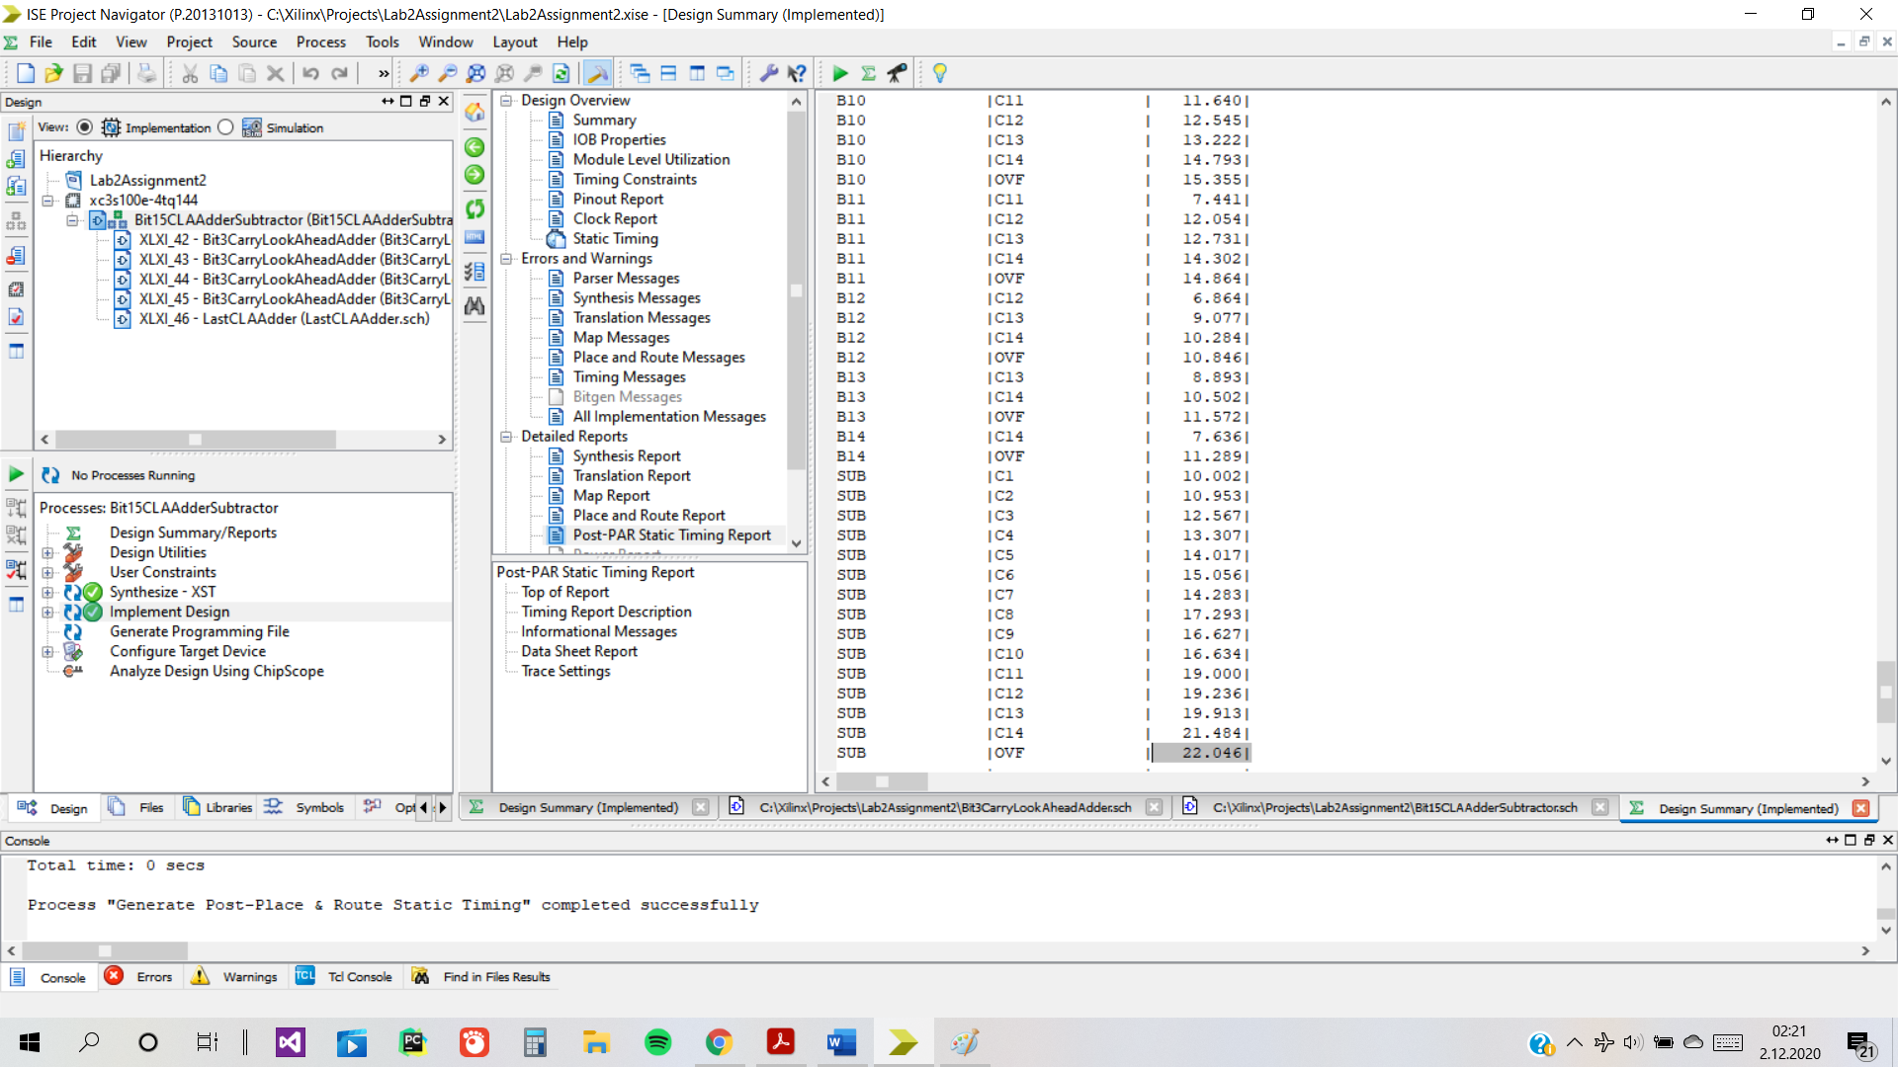

**4.Discussion**

Ripple carry using 15 full-adder is better in terms of area.

Carry-lookahead using 5 CLA adder is better in terms of speed.

NewMetric(Ripple-Carry) = 30*25.185=755,55

NewMetric(Carry-Lookahead) = 80*22.048=1763,84

Regarding the new metric Ripple Carry is better.

A good design should be both efficient in speed and area because that’s what engineering is all about. Elegance and efficiency are signs of a good design. For a design to be really good, it would have to have a good score with the new technique because that way it would actually be implemented in real life.